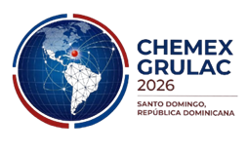
Press Accreditation Form
MINISTRY OF DEFENSE
CHEMEX GRULAC 2026
Applicant Personal Information
Full name
ID Document / Passport
Nationality
Contact number
Email address
Media Outlet
Media outlet name
Type of media | Print / Television / Radio / Digital
Position / Role | Journalist / Photographer / Cameraperson / Technician
Media outlet address
Media outlet phone number
Institutional email
Attached Requirements:
- Copy of ID document or passport
- Assignment letter from the media outlet
- Passport-size photograph (digital)

Declaration:
- I declare that the information provided is true and that I will comply with the accreditation rules and protocol established for the CHEMEX GRULAC 2026 event.
Applicant signature: ________________________________
Date: ________________________________
Send the filled-out form to:
relacionespublicas@mide.gob.do

